Depacketizer -RX Functional Design Specifications
  - Design and Implementation of CSI Controller IP
  - Version 4.0.1

  - Block Owner
Hana Samy Ahmed
  - Authors
Hana Samy Ahmed

This Page is left Blank Intentionally

Table of Contents
1 Table of Contents 1
2 Revision History 2
3 Overview 3
4 Operation and Description 3
4.1 Digital Interface 3
4.1.1 Parameters Names 3
4.1.2 Ports Names 3
4.2 Functional Description 3
4.3 Block Diagram 3
4.4 Timing Diagram 3
4.5 Verification Requirements 3

Revision History
Version | Date | Author(s) | Revision Notes | Owner Approval
1 | 6-2-2026 | Hana Samy

Overview
The RX Depacketizer serves as the protocol parsing layer of the video receiver pipeline. It receives a continuous raw byte stream, identifies packet boundaries, and splits the stream into its constituent components:
- Header: Extracted and sent to an External ECC Block.
- Payload: Extracted as "Active Video" and sent to the Unpacker.
- Payload + Footer: Sent to an External CRC Block for integrity verification.
The block operates in a "Push-Only" mode (no backpressure on the input) and supports a configurable CRC mode where the interface to the external CRC block can be enabled or disabled to save power.

Operation and Description

Digital Interface

Parameters Names
Parameter Name | Default | Description

Ports Names
Port Name | Port Width | Port Type | Description
System
i_clk | 1 | Input | System Clock.
i_rst_n | 1 | Input | Active-Low Asynchronous Reset.
Input Stream
i_rx_data | 8 | Input | Incoming raw byte stream (Header -> Payload -> Footer).
i_rx_valid | 1 | Input | Valid flag for input stream.
Output (to unpacker)
o_pay_data | 8 | Output | Extracted Active Video payload.
o_pay_valid | 1 | Output | Valid flag for video output.
o_pay_last | 1 | Output | Asserts on the last byte of the payload (End of Line).
o_pay_user | 1 | Output | Asserts on the first byte of a Frame (Start of Frame).
External ECC Interface
o_ecc_hdr_data | 32 | output | The 4-byte Packet Header sent to external ECC block.
External CRC Interface
o_crc_data | 8 | Output | Payload byte stream sent to external CRC block (includes Footer)..
o_crc_valid | 1 | Output | Valid flag for CRC calculation.
o_crc_start | 1 | output | Start marker for external CRC (asserted after header ends).
O_crc_end |  |  | End marker for external CRC (asserted on last payload byte).
Register Interface
i_cfg_crc_en | 1 | Input | CRC Mode: 1=Check CRC, 0=Ignore CRC (Disabled).
i_ecc_syndrome | 2 | Input | Response from ECC: 00=OK, 01=1-bit Err, 10=2-bit Err.
i_ecc_corr_hdr | 32 | Input | The corrected header (used if 1-bit error detected).

Functional Description
The Depacketizer operates as a Finite State Machine (FSM) that coordinates the data flow.
1. Header Phase (ECC Output)
- The block accumulates the first 4 bytes.
- The full 32-bit header is driven on o_ecc_hdr_data to the External ECC block.
2. Payload Phase (Video & CRC Start)
- The FSM streams bytes to both the Unpacker and the External CRC block.
- CRC Control:
  - o_crc_start pulses High on the First Payload Byte.
  - o_crc_valid stays High for the duration of the payload.
  - o_crc_end pulses High on the Last Payload Byte.
- Rationale: The o_crc_end signal tells the External CRC block: "This is the last byte to include in your checksum calculation."
3. Footer Phase (CRC Check)
- Immediately following the payload, the FSM receives the 2-byte Footer.
- To Unpacker: These bytes are dropped (not sent).
- To CRC Block:
  - The Footer bytes are passed to o_crc_data (with o_crc_valid High).
  - o_crc_end remains Low during these two cycles.
- Behavior: This implies the External CRC block uses o_crc_end to latch its calculated value, and then consumes the subsequent 2 bytes on o_crc_data to perform the comparison internally.

Block Diagram

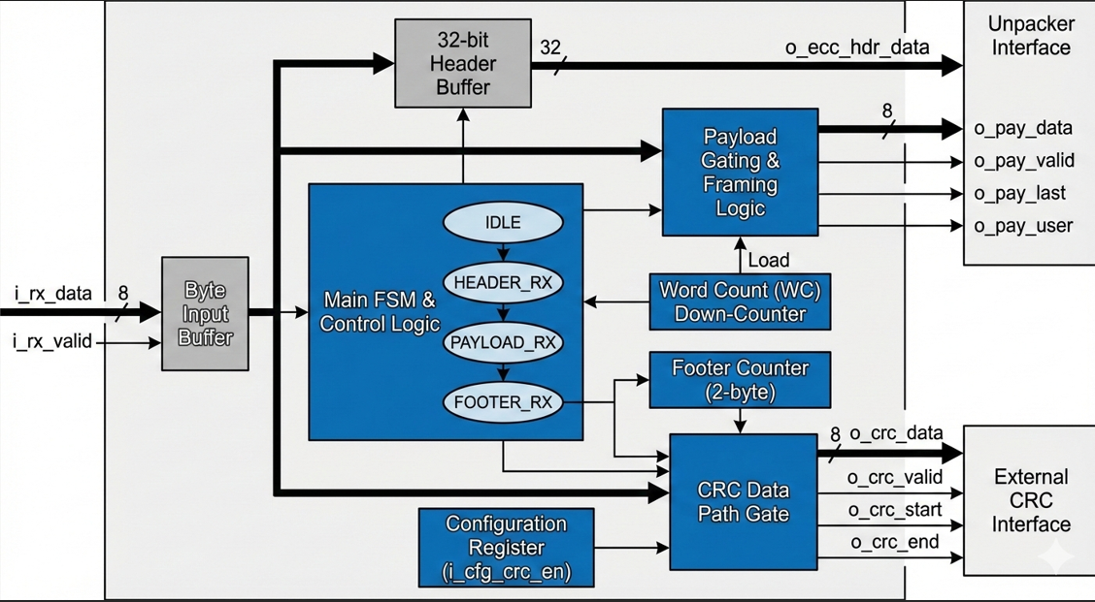

Timing Diagram
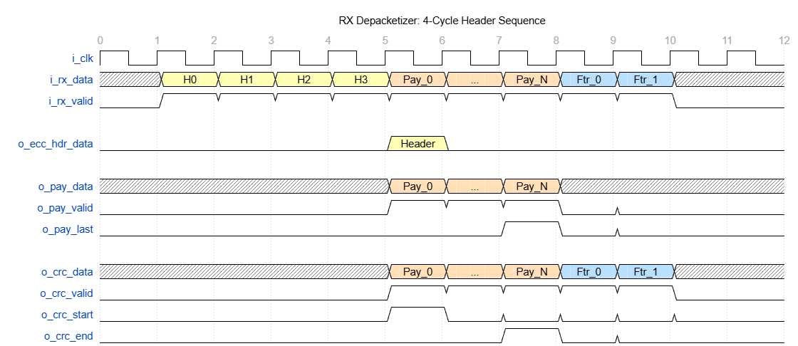

Verification Requirements
The verification plan must cover the interaction with the external blocks and the configuration modes:
- Mode Toggling: Verify that o_crc_valid remains Low when i_cfg_crc_en is set to 0, even while valid payload data is flowing to the Unpacker.
- Timing Alignment: Verify o_crc_start aligns exactly with the first payload byte and o_crc_end aligns with the last footer byte.
- Header Extraction: Ensure o_ecc_hdr_data is valid for at least one clock cycle immediately following the reception of the 4th header byte.
- Protocol Separation: Confirm that Header and Footer bytes never appear on the o_pay_data (Unpacker) interface.

